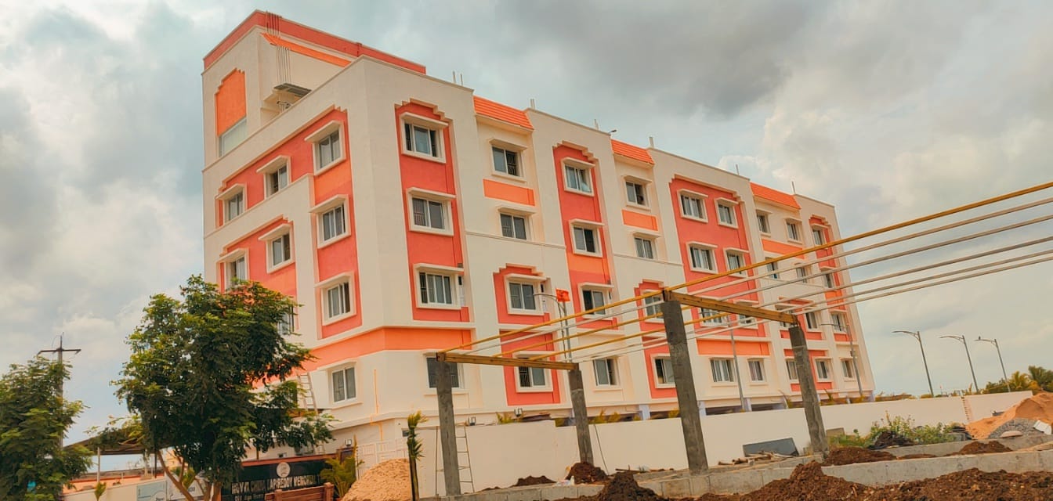
Making India Skill Capital of World
Ramky Foundation’s Contribution to India’s Skill Development Efforts: a Note

Ramky Foundation’s Contribution to India’s Skill Development Efforts: a Note

Background
Successive Indian Governments have opined on the need for skill development of the Indian work force. A multitude of schemes have been set up, both by private and public sectors to meet ambitious skill development goals. However, skill development and entrepreneurship efforts across the country have been highly fragmented so far. As opposed to developed countries, where the percentage of skilled workforce is between 60% and 90% of the total workforce, India records a low 5% of workforce (20-24 years) with formal vocational skills. There is a need for speedy reorganization of the ecosystem of skill development and entrepreneurship promotion in the country to suit the needs of the industry and enable decent quality of life to its population.
RF and Skill Development
Ramky Foundation facilitates or catalyses skill development initiatives that can potentially have a multiplier effect. In doing so, it strives to involve the various other stakeholders in all aspects ofskill development.
Our approach is to develop skills among women, youth, farmers, workers /labors of various industries and youth whist partnerships with multiple stakeholders and build long-term associations. To scale up efforts necessary to achieve the objective of skilling / up-skilling people, the RF strives to:
- Develop low cost, high-quality training with innovative business models
- Attract significant linkages which enable the long-term development

Objectives
- 3E: Employment-Employability-Entrepreneurship
- To generate employment opportunities for weaker sections of society by providing them skill based trainings
- To enhance the skills of farmers, workers /labors of various sectors, etc. to increase the productivity.
- To connect the trained beneficiaries to capital and job markets for their sustainable livelihoods.
- Enhanced Skill Development programs & follow-up training to impart skills required for advance level of activities

RF’s Initiatives
Since its inception in 2006, RF has organized various skill development programs to promote employment and entrepreneurship opportunities to the weaker sections of the society. RF proudly shares its achievement of skilling 4400 women and 8025 youth of several categories in various job roles. Following are the various sectors, in which RF facilitated skill up-gradation programs /activities to the beneficiaries in many parts of India;

1 | Web Developer
2 | Software Developer
3 | Telecom – Sector (BBT )
4 | Health Care - GDA (Nursing )
5 | Textile and apparel sector
6 | Fashion Designing
7 | Beautician course
8 | BPO (Voice & Non Voice)
9 | Hospitality
10 | Coir Yarn Making
11 | Construction Industry
12 | Accounting package – Tally, excel, etc.
13 | Computer Assistance
14 | Security Guards
15 | Jute Bag making
16 | Making of various Home Based Products
17 | Agriculture (Horticulture, Organic Farming, nursery raising, soil and water conservation, etc.)
18 | Agro Processing Industry
19 | Trainings on Leadership Development
20 | Solid Waste Management
21 | Fire Safety, First Aid, etc.
22 | Carpentry
23 | Plumbing, electrician, fitter, etc.
24 | Car Driving

Outcomes
- Established Two Skill Development Training Centers in Guntur, Andhra Pradesh & Hyderabad, Telangana titled RAMKY SKILL SCHOOLS wherein we are organizing the training programs under the Central Govt. scheme DDU-GKY with collaboration of AP & TS Govts.
- Established two more training centers in Narasaraopet, Guntur District and Vizag (Pharmacity) to conduct various trainings allied to Apparel and Construction Sectors in affiliation with NSDC.
- Established “Vennela Rural Mart” with the beneficiaries undergone training in textile and apparel sector and manufacturing of various readymade products.
- Placements given to trainees in various corporate organizations like TCL, WIPRO, COGNIZENT, TECH MAHENDRA, JIO, AIRTEL, POINEER, HATHWAY, HOSPITALS LIKE MAX CURE, KIMS, APOLLO, etc.
- No. of Vocational Training Programs organized: 52
- Other Skill based training programs: 45
- Women Trained in total: 4400
- Common interest groups formed: 80
- Employment opportunities provided: 3200
- Self-employed: 800
- Formation of Mutually Aided Cooperative Societies: 2
- Financial linkages and Marketing support

Employability-Entrepreneurship to Empowerment: our Impact model
- RF Started Skill Development Centers in AP & TS in 2021 and Trained 1000+ Candidates and placed 800+ Candidates in different organizations with Salary range of 12000/- to 35000/- per Month.
- RF formed Rural Mart in 2011 with 50 women
- Skill trainings were provided to them with the support of ATDC
- Rural mart obtained school uniforms stitching work from Rajiv Vidya Mission
- Turnover is Rs. 73,54,265 and having a Profit of Rs. 12,36,000 during 2011-15
- Formation of common interest thrift /micro finance groups
- Promotion of MACS with 200 members
- RF supports to procure machinery to establish sportswear readymade unit
- Loan support from NABARD for unit expansion
- Ramky Foundation is providing technical/marketing support
- Creation of Sustainable business model

Empanelment /Accreditation /Schemes
RF has conducted skill development trainings in collaboration /empanelment with various public and private sector organizations.

1 | DDU-GKY (Deen Dayal Upadhyaya Grameen Kaushalya Yojana )
2 | National Skill Development Corporation
3 | PMKVY (Pradhan Mantri Kaushal Vikas Yojana}
4 | NABARD
5 | Ministry of Women and Child Welfare Development
6 | Ministry of Minority Affairs
7 | Jana Sikshana Samsthan
8 | APITO
9 | PM DAKSH (Pradhan Mantri Dakshta Aur Kushalta Sampann Hitgrahi)
10 | ATDC (Apparel Training and Design Center)
11 | National Academy of Construction
12 | AP STEP
13 | IL&FS Skills
14 | Central Board for Workers Education
15 | Ramky Group
16 | NIIT

Current operations in Skill Development Sector across India
Sl. No. | Centre Location | Job Role
1 | Pedaparimi, Guntur Ditstrict, Amaravati, AP | Web Developer, Telecom – BBT, Health Care – GDA,  BPO Voice & Non Voice, Banking, Logistics & Electronics.
2 | Beeramguda, Hyderabad, Telangana State | Web Developer, Telecom – BBT, Health Care – GDA,  BPO Voice & Non Voice, Banking, Logistics & Electronics.
3 | Delhi | Mason general, Asst. Electrician
4 | Bangalore | Food & Beverages, Assist. Beauty Therapist
5 | Vizag | Asst. Electrician, Plumbing General, Apparel Sector, Sewing Machine Operator
6 | Narasaraopet (Center 1) | Sewing Machine Operator (SMO), Assist. Beauty Therapist
7 | Narasaraopet (Center 2) | Sewing Machine Operator(SMO), Self Employed Tailor
8 | PedaKakani | Security Supervisor, Car Driver, Tailoring

Authorized Training Partners for DDU-GKY & PMKVY
- RMAKY FOUNDATION is Authorized PIA (Project Implementing Agency) of DDU-GKY Project with PRN TS2017RT16458 and PMKVY.
- Implementing DDU-GKY Residential Placement linked Training Programs in Andhra Pradesh and Telangana States.
- So far we have trained nearly 1000+ candidates under DDU-GKY program (residential) within 10 months only.
- And trained more than 2000 candidates under PMKVY scheme.
- Successfully placed 83% of the trained candidates in various Organizations in the Sector of Telecom and ITeS.
Conclusion
Skill development is an imperative for our country at this point for several reasons. India is set to grow ‘younger’, with major population being in the working age group. This demographic will be actively looking for jobs, and can potentially drive domestic demand if they enjoy good economic status.
Corporate Office
H.No: 6-3-1089/G10&11,
RAMKY House,
Rajbhavan Road, Somajiguda,
Hyderabad – 500 082.
Tel. No: 040 44422222
About Ramky Foundation

Ramky Foundation - signatory of United Nations Global Compact and a not-for-profit partner of Ramky Group and has been registered under the Trust Act, Andhra Pradesh, Reg. No 412/06-IV. The Foundation emphasizes the credo – Towards Sustainable Growth. Since its inception in 2006, Ramky Foundation is proactively promoting the public interest by encouraging community growth and development, and voluntarily eliminating practices that harm the public sphere. With emphasis on four thrust areas - Natural resource management, Women empowerment, Education and Health, the Foundation is growing by leaps and bounds with definite strategies including successful collaborationswith different government and non-government agencies.

Mumbai
Ramky Foundation
9th Floor, Corporate Park-2, Sion - Trombay

Road,Chembur (East), Mumbai- 400071.
Ph: 022-67628888

Delhi
C-D-E, 6th Floor, 15 Hansalaya Building, Barakhamba Road, Connaught Place,
New Delhi - 110001

Kolkata
Jindal Towers, Block A, 4th Floor, 21/1A/3, Darga Road, Kolkata - 700017
Ph: 033 22892527

Visit us at:

www.ramkyfoundation.org

